Experiment No 7. Design and verify the Truth Table of 3-bit Parity Generator and 4-bit Parity Checker using basic Logic Gates with an even parity bit.

Description:

The parity generating technique is one of the most widely used error detection techniques for the data transmission. In digital systems, when binary data is transmitted and processed, data may be subjected to noise so that such noise can alter 0s (of data bits) to 1s and 1s to 0s.

Hence, parity bit is added to the word containing data in order to make number of 1s either even or odd. Thus it is used to detect errors , during the transmission of binary data. The message containing the data bits along with parity bit is transmitted from transmitter node to receiver node.

I) Parity Generator:

It is combinational circuit that accepts an n-1 bit stream data and generates the additional bit that is to be transmitted with the bit stream. This additional or extra bit is termed as a parity bit.

In even parity bit scheme, the parity bit is „0‟ if there are even number of 1s in the data stream and the parity bit is „1‟ if there are odd number of 1s in the data stream.

Even Parity Generator

Let us assume that a 3-bit message is to be transmitted with an even parity bit. Let the three inputs A, B and C are applied to the circuits and output bit is the parity bit P. The total number of 1s must be even, to generate the even parity bit P.

II) Parity Checker

It is a logic circuit that checks for possible errors in the transmission. This circuit can be an even parity checker or odd parity checker depending on the type of parity generated at the transmission end. When this circuit is used as even parity checker, the number of input bits must always be even.

When a parity error occurs, the „sum even‟ output goes low and „sum odd‟ output goes high. If this logic circuit is used as an odd parity checker, the number of input bits should be odd, but if an error occurs the „sum odd‟ output goes low and „sum even‟ output goes high.

Even Parity Checker

Consider that three input message along with even parity bit is generated at the transmitting end. These 4 bits are applied as input to the parity checker circuit which checks the possibility of error on the data. Since the data is transmitted with even parity, four bits received at circuit must have an even number of 1s.

If any error occurs, the received message consists of odd number of 1s. The output of the parity checker is denoted by PEC (parity error check).

Components Required:
IC 7486, Patch Cords & Digital Trainer Kit.

I) PARITY GENERATOR:

TRUTH TABLE:
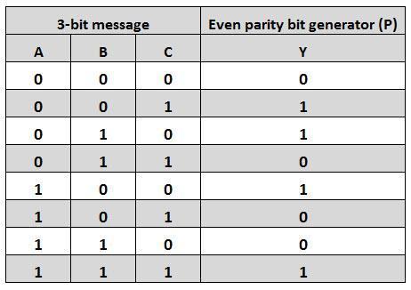

The K-map simplification for 3-bit message even parity generator is
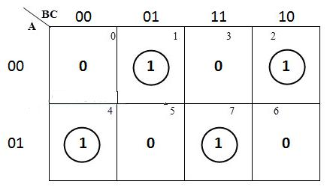

From the above truth table, the simplified expression of the parity bit can be written as
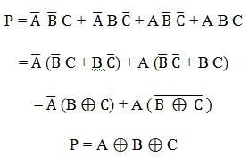

To generate the even parity bit for a 4-bit data, three Ex-OR gates are required to add the 4-bits and their sum will be the parity bit.

Circuit diagram: parity generator
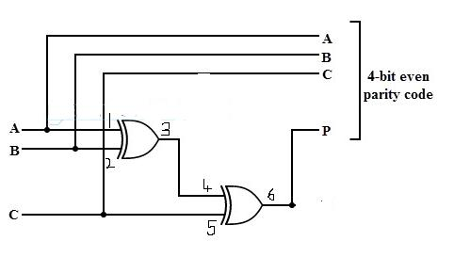

- PARITY CHECKER:

The below table shows the truth table for the even parity checker in which PEC = 1 if the error occurs, i.e., the four bits received have odd number of 1s and PEC = 0 if no error occurs, i.e., if the 4-bit message has even number of 1s.

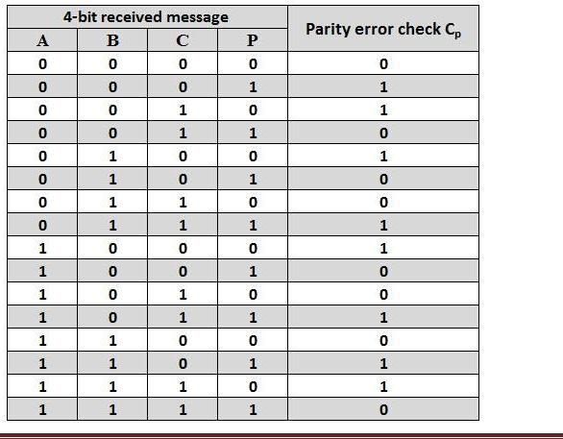

The above truth table can be simplified using K-map as shown below.
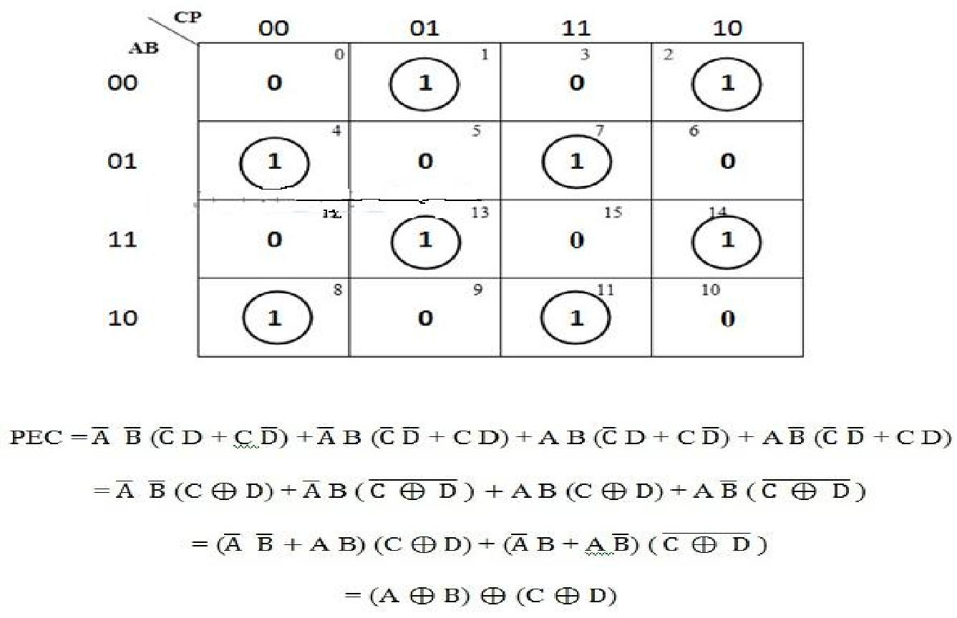

The above logic expression for the even parity checker can be implemented by using three Ex-OR gates as shown in figure. If the received message consists of five bits, then one more Ex-OR gate is required for the even parity checking.

Circuit diagram:
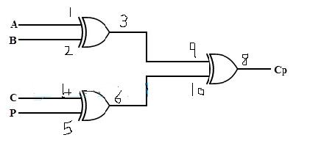

PROCEDURE:
- Check all the components for their working.
- Insert the appropriate IC into the IC base.
- Make connections as shown in the circuit diagram.
- Verify the Truth Table and observe the outputs.

RESULT: 3 bit parity generator and 4 bit parity checker is verified.

